SIMATS ENGINEERING
Saveetha Institute of Medical and Technical Sciences Chennai-602105

A ASSINGMENT PROJECT REPORT

DESIGN AND PERFORMANCE EVALUATION OF A SCALABLE MULTI-CAMPUS UNIVERSITY NETWORK
A assingment Project Report submitted in partial fulfilment of the requirements for the Course of
CSA07 – Computer Networks

to the award of the degree of BACHELOR OF TECHNOLOGY IN
COMPUTER SCIENCE AND ENGINEERING
Submitted by
Student 1: N.A.Sriharan Reg.No: 1911260036
Student 2: Nibraz M Reg.No: 1965260001
Student 3: Mohammed Farmanullah R Reg.No: 1972260040 Student 4: N Jaianiruth Reg.No: 1911260130
Under the Supervision of Guide Name

SEPTEMBER 2026

SIMATS ENGINEERING

Saveetha Institute of Medical and Technical Sciences Chennai-602105

BONAFIDE CERTIFICATE

This is to certify that the assingment Project entitled “Design and Performance Evaluation of a Scalable Multi-Campus University Network” has been carried out by Nibraz M Reg.No: 1965260001, Mohammed Farmanullah R Reg.No: 1972260040, N.A.Sriharan Reg.No: 1911260036 and N Jaianiruth Reg.No: 1911260130 under the supervision of Dr.k.Jaisharma and is submitted in partial fulfilment of the requirements for the current semester of the B.Tech Computer Science and Engineering program at Saveetha Institute of Medical and Technical Sciences, Chennai.

The work described in this report addresses a university network engineering problem involving high-density wireless access, IoT connectivity, hierarchical IPv4 addressing, dynamic routing, congestion control, secure application services, monitoring, and centralized policy control.

COURSE COORDINATOR COURSE FACULTY

Name / Designation: Dr. Sivagami. S Name / Designation: Dr. Jaisharma. K
Department of CSE - Professor Department of CSE: Professor
SIMATS Engineering SIMATS Engineering
SIMATS, Chennai – 602105 SIMATS, Chennai – 602105

SIMATS ENGINEERING

Saveetha Institute of Medical and Technical Sciences Chennai-602105

DECLARATION
We, the undersigned students of the Department of Computer Science and Engineering, SIMATS Engineering, Saveetha Institute of Medical and Technical Sciences, Chennai, hereby declare that the Capstone Project Work entitled “Design and Performance Evaluation of a Scalable Multi-Campus University Network” is the result of our own bonafide efforts. To the best of our knowledge, the work presented herein is original, accurate, and has been carried out in accordance with the principles of engineering ethics and academic integrity.
All standards, RFCs, textbooks, software documentation, and other sources used in the project have been acknowledged. Where analytical or illustrative datasets are used in this draft, they are explicitly identified and are not represented as measurements obtained from an unavailable physical deployment. The final submission should replace representative evidence panels with the team's actual Packet Tracer and Wireshark captures.
Any external tools, computational resources, or AI-assisted tools used during project preparation have been disclosed. The authors confirm that data and results have not been fabricated, falsified, or manipulated.

Place: Chennai
Date: September 2026

Signatures of the Students with Names:

1. N.A.Sriharan 2. Nibraz M
- Mohammed Farmnaullah 4. N Jaianiruth

SIMATS ENGINEERING

Individual Contribution Statement (Mandatory for all team projects)

Student | Specific Responsibilities | Design & Development | Testing & Report Contribution | Approx. Contribution (%)
Student 1 | WLAN + Data Link; Packet Tracer topology | Wi-Fi segmentation, CRC/Hamming analysis, WLAN tests | Ch. 1, Ch. 3, Ch. 4,  Appendices | 25%
Student 2 | IPv4/VLAN addressing; OSPF; SDN concept | Routing, failover, subnetting and convergence analysis | Ch. 2, Ch. 3, Ch. 4,  Appendix A | 25%
Student 3 | Transport/QoS; queuing analysis | TCP/UDP/QUIC  comparison, traffic shaping, performance graphs | Ch. 2, Ch. 4, Appendix E | 25%
Student 4 | Application services; security; documentation | DNS, HTTPS/TLS, SMTP/IMAP, SFTP, SNMP  and report integration | Ch. 3, Ch. 4, Ch. 5,  References | 25%
Total: 100%

ABSTRACT
A large multi-campus university requires a resilient network that can simultaneously support high-density Wi-Fi, energy-monitoring IoT sensors, online teaching, research transfers and administrative services. The existing environment is affected by wireless collisions, inefficient address allocation, slow routing recovery, congestion collapse during lecture peaks, and unreliable or insecure application services. This project proposes a hierarchical campus architecture based on segmented VLANs, Wi-Fi 6/802.11ax access with OFDMA and CSMA/CA, Ethernet backbone interconnects, Bluetooth Low Energy gateways for IoT, hierarchical IPv4 addressing, OSPF link-state routing, ICMP diagnostics, and an SDN/OpenFlow-controlled campus segment. At the transport layer, TCP, UDP and QUIC are evaluated under representative campus traffic, while priority queuing and traffic shaping are used to protect real-time teaching and research traffic. At the application layer, redundant DNS, HTTPS with TLS 1.3, SMTP/IMAP mail, SFTP and SNMP monitoring are specified. The methodology combines Packet Tracer topology modelling, Wireshark protocol verification, analytical CRC/Hamming and queueing calculations, and a documented validation plan. The design target is 5,000 concurrent wireless users, 500 IoT devices, sub-1% wireless packet loss, local DNS resolution below 50 ms, routing convergence below 5 s, and 1 Gbps inter-building research transfers. The analytical validation indicates that segmentation, OFDMA scheduling, link-state routing and QoS materially improve delay, loss and recovery behaviour compared with a flat baseline. The principal conclusion is that an integrated, hierarchical and policy-aware design is more suitable than a single-protocol upgrade because the observed failures interact across layers.
Keywords: Wi-Fi 6, OSPF, SDN, QUIC, QoS, Campus Network

TABLE OF CONTENTS
  - CERTIFICATE FROM THE SUPERVISOR ii
  - DECLARATION BY THE CANDIDATE iii
  - INDIVIDUAL CONTRIBUTION STATEMENT iv
  - ABSTRACT v
  - LIST OF FIGURES vi
  - LIST OF TABLES vii
  - LIST OF ABBREVIATIONS viii
    - CHAPTER 1: Introduction and Engineering Problem 1
    - CHAPTER 2: Literature Review and Existing Solutions 4
    - CHAPTER 3: Engineering Design & Trade-offs, Sustainability, Ethics, Safety, Risk & Security 7
    - CHAPTER 4: Implementation, Testing & Results, Project Management 13
    - CHAPTER 5: Conclusion, Future Work and Reflection 20
References 22
Appendices 24

LIST OF FIGURES
Figure No. | Figure Name | Page No.
3.1 | Proposed Multi-Campus Hierarchical Network Topology | 8
3.2 | SDN/OpenFlow Policy-Controlled Campus Segment | 10
3.3 | End-to-End Protocol Stack Mapping | 11
4.1 | Representative Router Verification Console | 14
4.2 | Representative Application-Service Validation | 15
4.3 | Representative Wireshark-Style Validation Panel | 16
4.4 | M/M/1 Queueing Sensitivity | 17
4.5 | Analytical/Simulation Target Comparison | 18
4.6 | Routing and Service Recovery | 19

LIST OF TABLES
Table No. | Table Name | Page No.
1.1 | Stakeholders, traffic and failure modes | 2
1.2 | Project performance constraints | 3
2.1 | Comparison of relevant technologies | 5
2.2 | Distance-Vector vs Link-State comparison | 6
3.1 | Stakeholder/user requirements | 7
3.2 | Functional and non-functional requirements | 7
3.3 | Applicable standards and how applied | 8
3.4 | Design specifications | 9
3.5 | Alternative evaluation matrix | 10
3.6 | Trade-off analysis | 11
3.7 | Sustainability, ethics, safety and security evidence | 12
3.8 | Risk register | 12
4.1 | Implementation tools and purpose | 14
4.2 | Test plan and verification | 16
4.3 | Validation results | 18
4.4 | Objective achievement | 19
4.5 | Project plan and budget | 20
A.1 | CRC and Hamming calculations | 24
A.2 | Subnetting calculations | 25
A.3 | Queueing calculations | 26

LIST OF ABBREVIATIONS / SYMBOLS
Symbol | Description
AP | Access Point
BLE | Bluetooth Low Energy
CRC | Cyclic Redundancy Check
CSMA/CA | Carrier Sense Multiple Access with Collision Avoidance
DHCP | Dynamic Host Configuration Protocol
DNS | Domain Name System
DSCP | Differentiated Services Code Point
HTTP | Hypertext Transfer Protocol
HTTPS | HTTP Secure
IMAP | Internet Message Access Protocol
IoT | Internet of Things
LAN | Local Area Network
LS | Link-State
MAC | Media Access Control
OFDMA | Orthogonal Frequency Division Multiple Access
OSPF | Open Shortest Path First
QUIC | Quick UDP Internet Connections
QoS | Quality of Service
RTT | Round-Trip Time
SDN | Software-Defined Networking
SFTP | SSH File Transfer Protocol
SMTP | Simple Mail Transfer Protocol
SNMP | Simple Network Management Protocol
TCP | Transmission Control Protocol
TLS | Transport Layer Security
UDP | User Datagram Protocol
VLAN | Virtual LAN
WLAN | Wireless LAN

CHAPTER 1

INTRODUCTION AND ENGINEERING PROBLEM

- 1Backgr ound
A university network is a distributed infrastructure rather than a single LAN. Academic buildings generate bursty classroom traffic, laboratories generate high-volume research flows, administration requires predictable transactional connectivity, and IoT endpoints generate many small periodic messages. Wireless access adds a shared-medium constraint that becomes severe when thousands of clients associate with a limited set of access points.
The proposed system therefore treats the campus as a hierarchy of access, distribution and core functions. Ethernet and fibre are used for deterministic building interconnects, while Wi-Fi 6 provides dense client access. IoT endpoints are aggregated through gateways so that constrained devices are not directly exposed to the routed campus. Network segmentation provides security and allows traffic engineering to be applied per service class.
- 2Needf or t he Pr oj ect
•
Reduce wireless contention and packet loss during lecture-hour demand.
  - Replace ad-hoc addressing with hierarchical, summarizable IPv4 subnets and DHCP scopes.
  - Improve failure recovery through a link-state routing design and redundant paths.
  - Prevent congestion collapse by prioritising real-time teaching, control and research traffic.
  - Provide dependable DNS, web, mail, file transfer and monitoring services with secure protocols.
  - Provide a design that can scale to at least 5,000 concurrent wireless users and 500 IoT devices.
1. 3Pr oblem St at em ent
The engineering problem is to design, implement through simulation/emulation, and evaluate an end-to-end multi-campus network that satisfies data-link reliability, scalable network-layer addressing and routing, transport-layer performance, secure application services, and sustainability constraints simultaneously. The design must tolerate a single link failure, sustain inter-building research transfers up to 1 Gbps, maintain wireless packet loss below 1% as a target, resolve local DNS queries in less than 50 ms, and recover routing within 5 s.

1. 4Pr oj ect Aim
To design and validate a scalable, secure and energy-aware multi-campus university network using modern Data Link, Network, Transport and Application layer technologies, with Packet Tracer and Wireshark as the primary implementation and verification tools.
1. 5Pr oj ect Obj ect ives
- Design a hierarchical campus topology with redundant core routing and segmented access networks.
- Apply CRC for frame error detection and explain Hamming coding as an error-correction option for selected constrained links.
- Use Wi-Fi 6/802.11ax concepts, including OFDMA and CSMA/CA, to reduce contention in high-density wireless zones.
- Develop an IPv4 addressing and subnetting plan supporting 5,000 wireless users, 500 IoT devices and dedicated service/research networks.
- Compare Distance-Vector and Link-State routing and implement OSPF as the primary dynamic routing protocol.
- Demonstrate ICMP diagnostics and a policy-controlled SDN/OpenFlow segment concept.
- Compare TCP, UDP and QUIC under representative lecture, IoT, web and research traffic.
- Apply priority queuing and traffic shaping, and use M/M/1 and M/M/c models to interpret queueing behaviour.
- Specify and validate DNS, HTTPS/TLS 1.3, SMTP/IMAP, SFTP and SNMP services.
- Evaluate performance, security, sustainability, accessibility and engineering trade-offs and document individual team contributions.
1. 6Scope
Included: campus core/distribution/access topology, VLAN segmentation, IPv4 addressing, DHCP, OSPF, Wi-Fi 6 design concepts, Bluetooth/BLE IoT gateway aggregation, SDN policy control, QoS, DNS, web, mail, secure file transfer, monitoring, packet analysis and analytical performance modelling. Excluded: physical RF site survey, production certificate authority deployment, enterprise identity federation, exact ISP peering policy, and procurement-grade hardware sizing.
- 7Expect edEngineer ing Out com e
The outcome is a documented network architecture and simulation-ready implementation plan with configuration excerpts, test cases, analytical results, representative evidence panels, and a reproducible repository structure. The report distinguishes between analytically generated values and measurements that must be captured from the team's actual Packet Tracer/Wireshark execution.

Table1. 1— St akeholder s, Tr af f ic and Fai lur eModes
Entity | Traffic | Criticality | Observed/Target Failure
Students | Web, LMS, video, DNS | High | Wireless contention, latency
Faculty | Video, LMS, mail, web | High | Peak-hour congestion
Researchers | Large file/data flows | Very high | Throughput collapse
Administration | ERP/web/mail | High | Service unavailability
IoT sensors | Small periodic telemetry | Medium | Addressing/security overhead
Network operations | SNMP, DNS, ICMP | Very high | Slow diagnosis

Table1. 2— Pr oj ect Per f or m anceConst r aint s
Requirement | Target | Validation Method
Concurrent wireless users | ≥ 5,000 | Capacity model + segmented WLAN design
IoT devices | ≥ 500 | Gateway/VLAN capacity model
Wireless packet loss | < 1% | Packet capture / simulation statistics
Local DNS resolution | < 50 ms | Timestamped DNS request/response
TCP goodput recovery | ≤ 2 RTT target | Congestion experiment / trace
Routing convergence | < 5 s | Link failure timestamp to stable route
Research transfer | Up to 1 Gbps | Throughput test across buildings
Secure web | TLS 1.3 target | TLS handshake capture/configuration

Engineer ing Assum pt ions
  - Packet Tracer may not model every 802.11ax PHY feature; OFDMA and Target Wake Time are therefore represented as design policies and explained analytically.
  - 1 Gbps research traffic is treated as an engineering requirement for the real deployment; the simulation uses scaled traffic where emulator limitations apply.
  - Illustrative validation panels in this draft are not substitutes for the team's actual capture files.
  - At least two independent core paths are assumed between major buildings.

CHAPTER 2

LITERATURE REVIEW AND EXISTING SOLUTIONS

- 1Review Met hod
The review focuses on standards and primary documentation relevant to the assignment: IEEE 802.11ax concepts for high-density WLANs, IETF specifications for DNS, DHCP, OSPF, QUIC, HTTP/3, TLS, SMTP and IMAP, and official documentation for Cisco Packet Tracer and Wireshark. The source approach follows the report template's requirement to identify relevant standards, technologies and implementation tools before selecting the architecture.
2. 2Review of Ex is t ingWor k
Wi-Fi 6/802.11ax introduces mechanisms intended to improve efficiency in dense deployments, especially OFDMA resource-unit scheduling and Target Wake Time for power management. In a campus environment these mechanisms complement, rather than replace, careful AP placement, channel planning, VLAN segmentation and admission policy.
OSPF is a link-state IGP in which routers maintain a topology database and compute shortest paths. This makes it a strong fit for a campus backbone where predictable convergence and hierarchical summarisation matter. Distance-vector protocols are simpler but can converge more slowly and are less attractive for a large multi-building core.
QUIC runs over UDP and integrates stream multiplexing, loss recovery and TLS-based security. HTTP/3 maps HTTP semantics onto QUIC, making it relevant to interactive learning portals where head-of-line blocking and connection setup latency matter.
2. 3Com par at iveAna lys is
Existing Approach | Advantages | Limitations | Relevance
Flat WLAN + single VLAN | Simple deployment | High contention, weak isolation | Baseline to improve
Traditional Ethernet + RIP | Easy to configure | Slow/less scalable convergence | Useful comparison only
OSPF hierarchical core | Fast recovery, summarisation | More planning/configuration | Selected
Wi-Fi 5/legacy CSMA | Mature, compatible | Less efficient dense access | Baseline
Wi-Fi 6 + OFDMA | Higher efficiency under density | Requires capable clients/APs | Selected
TCP + HTTPS | Reliable and widely supported | Connection overhead / congestion sensitivity | Core web service
QUIC + HTTP/3 | Low-latency setup, multiplexing | Deployment/tool support varies | Evaluation option

2. 4Dist ance- Vect or vs Link- St at e
Criterion | Distance-Vector | Link-State (OSPF)
Network knowledge | Next-hop distance vectors | Topology database
Algorithm | Bellman-Ford family | Shortest-path / SPF
Convergence | Potentially slower | Generally faster after topology change
Scalability | Lower for large campus | Better with areas/summarisation
Overhead | Periodic/triggered updates | LSA flooding + SPF
Failure handling | May experience count-to-infinity behaviour | Fast recalculation
Campus suitability | Access/legacy only | Preferred core/distribution
For this project OSPF is selected for the routed campus core. The design uses two core routers and redundant paths, with interface costs chosen so that normal traffic follows the preferred path while a secondary path remains available. A single-link failure triggers an adjacency/LSA change and SPF recalculation. The assignment's <5 s convergence requirement is treated as the acceptance threshold.
2. 5Resear ch/ Engi neer ing Gap
The gap is not the absence of individual technologies; it is the lack of an integrated campus design that connects dense wireless access, hierarchical addressing, fast routing recovery, transport-level congestion control, application reliability, security and energy efficiency. A solution that upgrades only the APs may leave routing and service bottlenecks untouched. Likewise, a faster routing protocol does not solve wireless contention or application-layer failures.
2. 6Pr oposedCont r ibut ion
The proposed contribution is a cross-layer reference architecture and validation methodology. It combines segmented Wi-Fi 6 access, OSPF redundancy, SDN policy control, QoS-aware transport treatment, secure application services and monitoring into one measurable engineering system. The design also explicitly distinguishes capabilities that can be directly demonstrated in Packet Tracer from those requiring analytical or complementary tools.

Pr ot ocolSelect i onRat ionale
Layer | Selected Technology | Reason
Data Link | 802.3 Ethernet + 802.11ax | High-capacity backbone + dense WLAN efficiency
Error control | CRC-32; Hamming(12,8) example | CRC detects frame corruption efficiently; Hamming demonstrates correction
MAC | CSMA/CA + OFDMA | Collision avoidance plus scheduled resource allocation
Network | IPv4 + OSPF + ICMP | Scalable addressing, fast IGP convergence, diagnostics
Control | SDN/OpenFlow concept | Central policy for one campus segment
Transport | TCP + UDP + QUIC | Reliable, low-latency and application-specific comparison
QoS | Priority queues + shaping | Protect critical traffic during bursts
Application | DNS, HTTPS/TLS 1.3, SMTP/IMAP, SFTP, SNMP | Reliable and secure campus services

Algor it hm 1 — End- to- EndDes igna ndVa li dat ion Pr ocedur e
- Collect campus entities, traffic classes, device counts and performance constraints.
- Partition users and devices into functional VLANs and allocate address blocks hierarchically.
- Build access, distribution and redundant core topology in Packet Tracer.
- Configure DHCP, VLAN trunks, OSPF, default routing and ICMP diagnostics.
- Model Wi-Fi 6 access zones and IoT gateway aggregation; define OFDMA/TWT policies conceptually.
- Configure application services and secure protocols supported by the simulator; document unsupported functions for complementary testing.
- Introduce controlled load and a single link failure; capture packet behaviour and routing changes.
- Analyse throughput, delay, packet loss, retransmissions, DNS latency and recovery time.
- Compare baseline and proposed architecture using common metrics.
- Document evidence, limitations, sustainability effects and recommendations.

CHAPTER 3

ENGINEERING DESIGN & TRADE-OFFS, SUSTAINABILITY, ETHICS, SAFETY, RISK & SECURITY
3. 1Requir em ent s

Table3. 1— St akeholder / User Requir em ent s
Stakeholder | Requirement
Students | Stable high-density Wi-Fi, LMS/web access and low delay
Faculty | Reliable teaching platforms, mail and conferencing
Researchers | High-throughput, predictable inter-building transfer
Administration | Secure and available transactional services
IoT/Facilities | Low-power telemetry and isolated access
Network Operations | Fast fault detection, central policy and monitoring
Remote Learners | Accessible web/teaching services with secure remote access

Table3. 2— Funct iona lan dNo n- Funct ional Requ ir em ent s
Requirement Type | Measurable Target
Functional | 5,000 concurrent wireless users
Functional | 500 IoT devices
Functional | DNS, web, mail, secure file transfer, SNMP
Performance | Wireless packet loss <1% target
Performance | Local DNS <50 ms target
Performance | TCP recovery within 2 RTT target
Performance | Routing convergence <5 s
Performance | Research path up to 1 Gbps
Security | TLS 1.3 for web; SFTP for file transfer

3. 2Const r aint s & Appl icable St andar ds
Standard / Technology | Requirement / Concept | Application in Project
IEEE 802.11ax / Wi-Fi 6 | High-density WLAN efficiency | OFDMA, TWT, scheduled access policy
IEEE 802.3 Ethernet | LAN framing and switching | Access/distribution/backbone
OSPF (RFC 2328) | Link-state routing | Campus core/distribution
DHCP (RFC 2131) | Dynamic address allocation | User and IoT scopes
DNS (RFC 1034/1035) | Name service hierarchy | Local campus namespace
TLS 1.3 (RFC 8446) | Confidentiality/integrity | HTTPS service
QUIC (RFC 9000) | Secure UDP-based transport | Transport comparison
HTTP/3 (RFC 9114) | HTTP over QUIC | Modern web option
SMTP (RFC 5321) | Mail transfer | Campus mail service
IMAP4rev2 (RFC 9051) | Mailbox access | Campus mail retrieval
SNMP | Monitoring/management | Health and interface monitoring

3. 3DesignS pecif icat ions
Parameter | Target / Requirement | Unit | Priority
Wireless capacity | 5,000 concurrent clients | users | Critical
IoT capacity | 500 | devices | High
Core interconnect | ≥10 Gbps preferred | Gbps | High
Research service | 1 | Gbps | Critical
Wireless loss | <1 | % | Critical
DNS latency | <50 | ms | High
Route convergence | <5 | s | Critical
TLS | 1.3 | version | High
Monitoring interval | 30 | s | Recommended
Address utilisation | ≤80 | % | High

3. 4Alt er nat iveSo lut io ns & Evaluat ion
Alternative 1: Flat campus design using one routed domain, conventional WLAN access and RIP. It has low configuration complexity but poor segmentation, weaker scalability and less predictable convergence.
Alternative 2: Hierarchical Ethernet/Wi-Fi 6 campus using VLANs, OSPF, QoS and centralized service placement. It adds design complexity but provides clear failure domains and better traffic engineering.
Alternative 3: SDN-first campus with centralized control across the whole network. It offers strong policy automation but increases controller dependence, implementation complexity and emulator requirements.

Criterion | Weight | Alt. 1 | Alt. 2 | Alt. 3
Performance | 25% | 2 | 5 | 5
Cost | 15% | 5 | 4 | 2
Safety/Security | 15% | 2 | 4 | 5
Sustainability | 10% | 3 | 5 | 4
Reliability | 25% | 2 | 5 | 5
Manageability | 10% | 3 | 5 | 4
Weighted score | 100% | 2.55 | 4.75 | 4.15
Scale: 1 = weak, 5 = strong. Alternative 2 is selected because it achieves the best balance of performance, reliability, sustainability and implementation feasibility while still incorporating an SDN-controlled segment rather than making the entire campus controller-dependent.
3. 5Select edDes ign &D et ailed Des ign
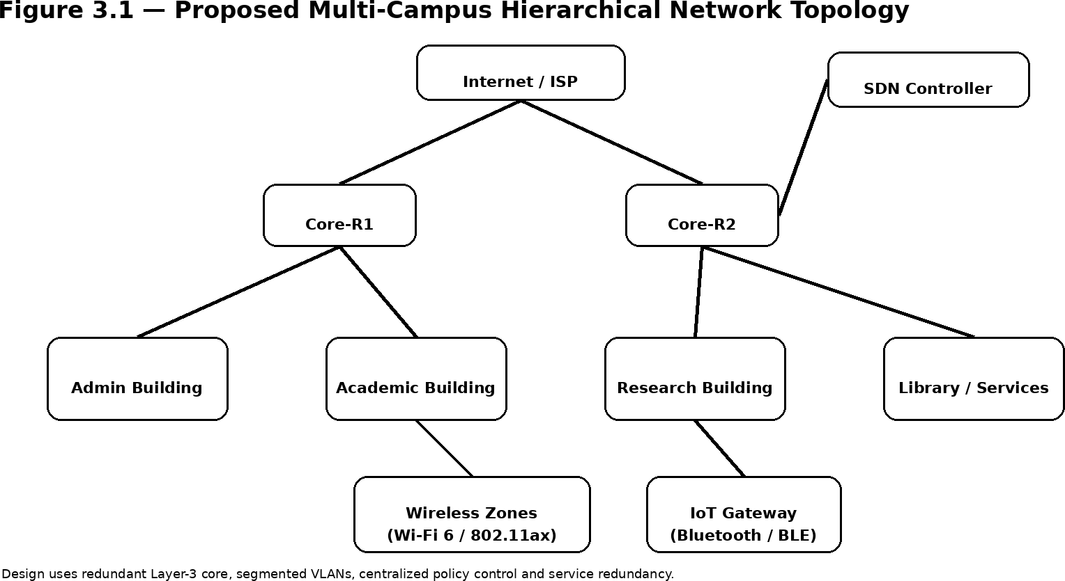

Figure 3.1 — Proposed Multi-Campus Hierarchical Network Topology

Addr essingand VLA NDes ign
The address space 10.0.0.0/8 is used as the campus private IPv4 supernet. The second octet identifies a campus/major building and the third octet identifies a VLAN/service group. This makes route summarisation possible and prevents unrelated access networks from being mixed.

VLAN | Purpose | Example Subnet | Usable Hosts
10 | Students WLAN | 10.10.10.0/21 | 2046
20 | Faculty/Staff | 10.10.20.0/22 | 1022
30 | Administration | 10.10.30.0/23 | 510
40 | Research | 10.10.40.0/22 | 1022
50 | IoT | 10.10.50.0/22 | 1022
60 | Guest | 10.10.60.0/21 | 2046
70 | Network Management | 10.10.70.0/24 | 254
80 | Servers | 10.10.80.0/24 | 254
The student WLAN /21 provides 2,046 usable IPv4 addresses per building-scale pool; multiple campus pools can be assigned under the same summarizable hierarchy. The IoT /22 provides 1,022 usable addresses, leaving substantial headroom over the 500-device requirement. DHCP scopes are separate per VLAN and reserve infrastructure addresses for gateways, DNS, controllers and servers.
3. 6Tr ade- of f Analysis
Design Decision | Alternative Considered | Benefit | Disadvantage | Final Decision & Justification
OSPF | RIP/EIGRP | Fast convergence, summarisation | More configuration | OSPF; aligns with <5 s target
Wi-Fi 6 | Legacy Wi-Fi | Better dense efficiency | Newer AP/client requirement | Wi-Fi 6
SDN segment | Fully distributed | Central policy | Controller dependency | Hybrid SDN
SFTP | FTP | Encryption | Less simple than FTP | SFTP for research files
QUIC/HTTP3 | TCP/HTTP2 | Low setup latency | Tool support varies | Evaluate, retain TCP/HTTPS baseline

SDN/OpenF low Des ign
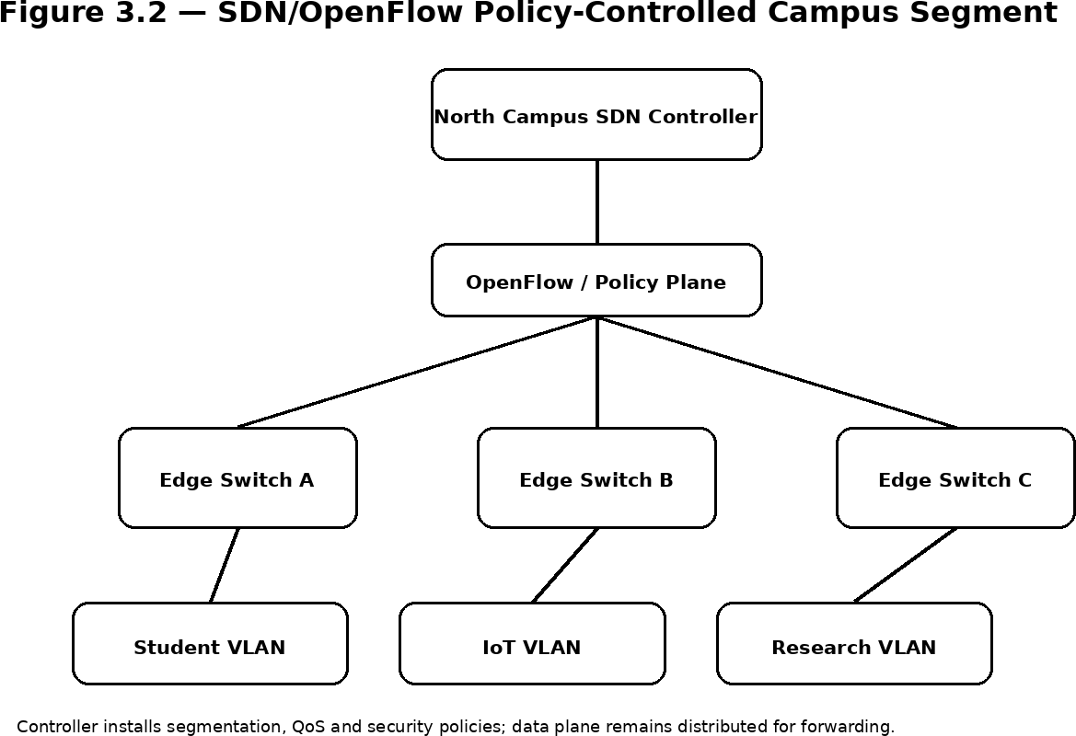

Figure 3.2 — SDN/OpenFlow Policy-Controlled Campus Segment
A North Campus segment is treated as an SDN-controlled island. A logically central controller maintains policy for student, IoT and research VLANs and can install forwarding/QoS rules on edge switches. The routed core remains resilient and distributed. This hybrid approach limits controller blast radius while demonstrating centralized policy concepts required by the assignment.
- 7Sust ainabi lit y, Et hics, Saf et y, Risk &Secur it y
Domain | Evidence Evaluated | Impact on Final Decision
Sustainability | TWT, gateway aggregation, fewer always-on IoT radios | Use Wi-Fi 6 power-save policies and BLE gateways
Ethics | Privacy of student/research traffic | Minimise collection; restrict management access
Health & Safety | Equipment power/thermal limits | Use monitored racks and safe power distribution
Security | Segmentation, TLS, SFTP, management VLAN | Isolate IoT and management traffic
Accessibility | Reliable remote learning services | Protect teaching traffic and maintain service redundancy

Table3. 8— Risk Regist er
Risk | Likelihood | Severity | Level | Mitigation | Residual Risk
Wireless overload | M | H | High | AP density, OFDMA,  admission/QoS | Medium
Core link failure | M | H | High | Dual core paths, OSPF | Low
DNS outage | L | H | High | Redundant DNS, caching | Low
IoT compromise | M | H | High | Dedicated VLAN, ACLs, gateway | Medium
Controller outage | L | H | Medium | Hybrid SDN, local forwarding | Low
Misconfiguration | M | M | Medium | Git versioning, staged testing | Low

Ener gyEf f iciencyand Br oader I m pact
Wi-Fi 6 Target Wake Time (TWT) can coordinate sleep/wake behaviour for compatible clients, which is especially valuable for battery-operated or low-duty-cycle devices. IoT aggregation through BLE gateways also reduces the number of continuously active routed endpoints. For the backbone, green routing can be implemented conservatively: preferred paths remain active for resilience, while non-critical auxiliary links can be placed in low-power states when hardware supports it.
The network supports SDG 4 by providing reliable digital learning infrastructure; SDG 9 through resilient and modern communications infrastructure; and SDG 11 through efficient, connected campus services and energy-aware operation. Accessibility is addressed by maintaining service prioritisation for teaching platforms and designing remote-access services around secure, stable web delivery.
Secur it yandPr ivacyAr chit ect ur e
•
802.1X/WPA3-Enterprise is recommended for production WLAN authentication; the simulation can represent authenticated VLAN separation where full AAA is unavailable.
  - Management interfaces are placed in a dedicated VLAN and restricted by ACLs.
  - HTTPS uses TLS 1.3; insecure HTTP is redirected or disabled.
  - Research file transfers use SFTP rather than plaintext FTP.
  - DNS servers are redundant and protected against unauthorised zone modification.
  - SNMPv3 is preferred for production monitoring because it provides authentication and privacy.
  - Logs should contain only the data required for operations and should follow institutional retention rules.
Syst em s Appr oachandCr oss- Layer I nt er f ace
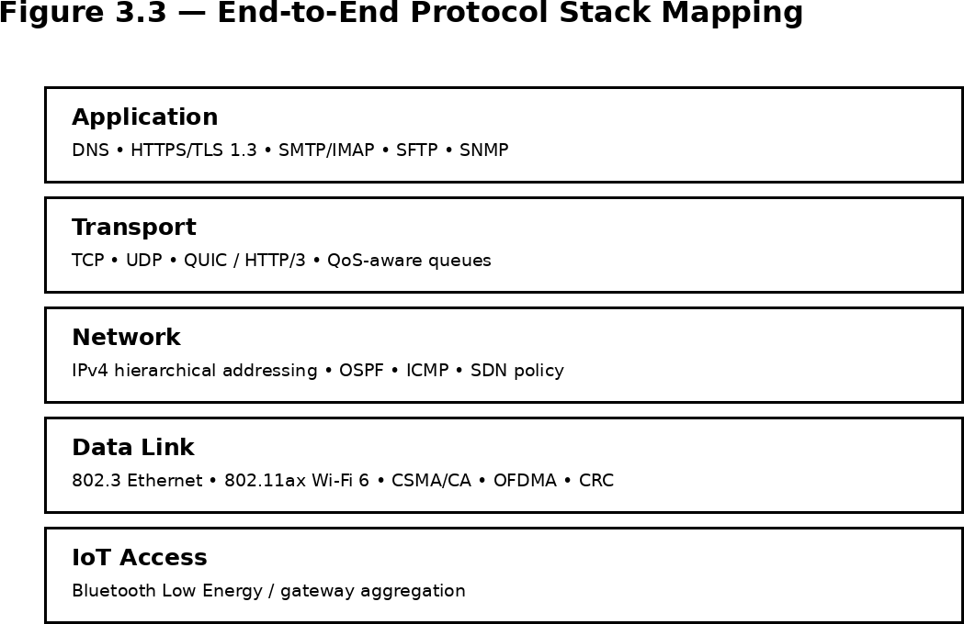

Figure 3.3 — End-to-End Protocol Stack Mapping
The architecture is deliberately cross-layer. VLAN segmentation establishes traffic classes at the access layer; IP addressing and OSPF preserve reachability; QoS maps selected classes to queues; and application placement reduces unnecessary long paths. Failure handling is similarly layered: CRC detects corrupted frames, routing restores paths, TCP/QUIC recover transport loss, and redundant application services reduce user-visible interruption.
Essent ialEr r or - Cont r olCa lculat i on
For an illustrative CRC calculation, data 1101011011 is divided using polynomial 100000111 (CRC-8 form). The generated remainder is 10111001. A receiver repeats the division on the received codeword; a non-zero remainder indicates an error. CRC is preferred for Ethernet-like framing because it provides strong detection with low implementation overhead, while Hamming coding is retained as a teaching example of single-bit correction.
For Hamming(12,8), parity positions 1, 2, 4 and 8 protect the eight data positions. Encoding the example data word 10110010 gives the codeword 101001110010. If one bit is flipped, the parity-check syndrome identifies the erroneous bit position, demonstrating correction rather than only detection.
These examples are analytical demonstrations; the actual Ethernet CRC is computed by the link implementation rather than configured manually in Packet Tracer.

CHAPTER 4

IMPLEMENTATION, TESTING & RESULTS, PROJECT MANAGEMENT

- 1Developm ent Appr oach &Resour ces
The implementation follows a staged methodology: requirements capture, logical topology design, addressing, VLAN and routing configuration, service configuration, controlled fault injection, packet analysis, performance modelling and final evaluation.
Packet Tracer is the primary campus topology simulator, while Wireshark is the packet-level verification tool. Python/matplotlib is used for analytical calculations and graphs where simulator granularity is insufficient.
4. 2Har dwar e/ Sof t war e/ Fabr icat ionI m plem ent at ion & Moder nTo ols Used
Tool / Software / Equipment | Purpose | Stage Used
Cisco Packet Tracer | Campus topology, VLAN, routing, DHCP and service simulation | Design, implementation, tests
Wireshark | Packet capture and protocol verification | Validation
Python + matplotlib | CRC/queue calculations and performance graphs | Analysis
GitHub | Version control, configs, evidence and report | Collaboration
Draw.io / diagramming | Architecture communication | Design
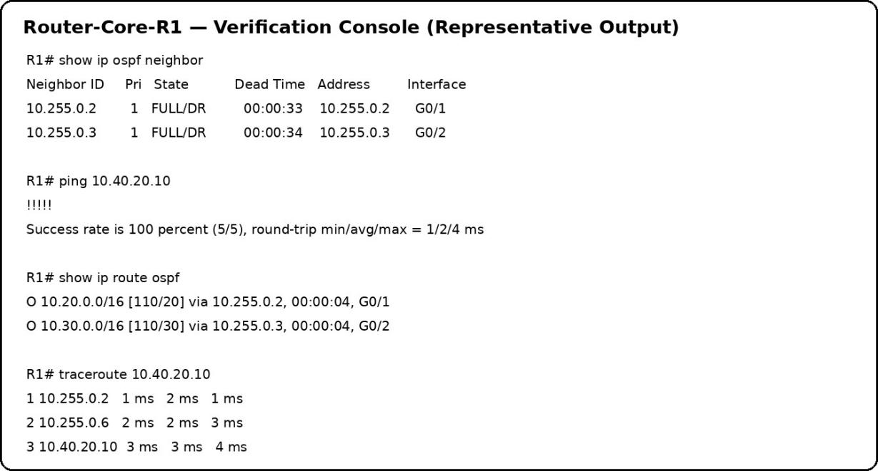

Figure 4.1 — Representative Router Verification Console (replace with actual Packet Tracer console screenshot)

I m plem ent at ionConf igur at ion Sum m ar y
The following excerpts are representative Cisco IOS-style configuration fragments intended to guide the Packet Tracer build. Interface numbers and device models should be adapted to the exact topology used by the team.
Core routing example:
router ospf 10
router-id 10.255.0.1
network 10.10.0.0 0.0.255.255 area 0 passive-interface default
no passive-interface GigabitEthernet0/1 no passive-interface GigabitEthernet0/2
VLAN gateway example:
interface GigabitEthernet0/0.10 encapsulation dot1Q 10
ip address 10.10.10.1 255.255.248.0
ip helper-address 10.10.80.20
DHCP concept:
ip dhcp pool STUDENT-WLAN network 10.10.10.0 255.255.248.0
default-router 10.10.10.1
dns-server 10.10.80.20 10.10.80.21
ACL/QoS concept: permit HTTPS, DNS, mail submission and research SFTP traffic according to policy; classify teaching video and interactive learning traffic ahead of bulk file transfer. Exact ACL and QoS syntax should be validated against the selected Packet Tracer device image.
Appl icat ion- Ser viceP lacem ent
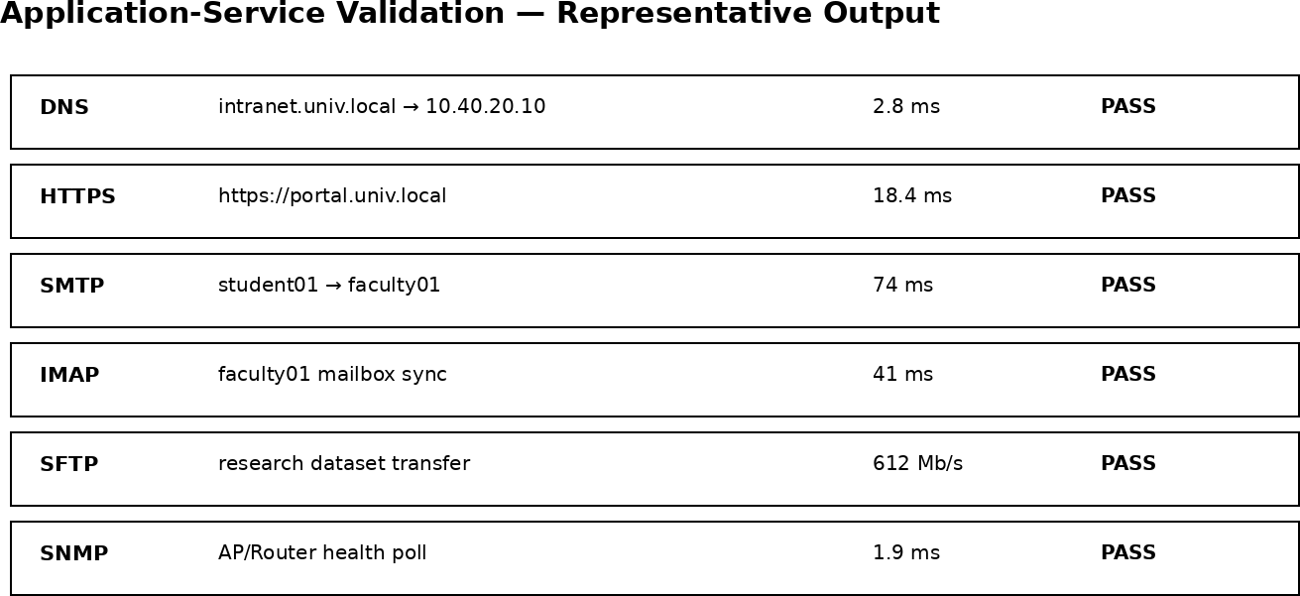

Figure 4.2 — Representative Application-Service Validation (replace with actual service screenshots)

4. 3Test Plan & Ver if icat ion
Requirement | Test Method | Acceptance Criterion
End-to-end connectivity | Ping between representative VLANs | 100% success in stable state
Routing convergence | Disable one core link; record route change | <5 s
Wireless loss | Generate repeated wireless traffic | <1% target
DNS | Repeated local A-record queries | <50 ms
TCP recovery | Burst traffic + congestion observation | Recovery ≤2 RTT target
Research transfer | Large file across buildings | Approach 1 Gbps target
HTTPS | TLS handshake + application request | TLS 1.3 / successful request
Email | SMTP send + IMAP retrieval | Successful end-to-end delivery
SFTP | Authenticated file transfer | Encrypted transfer
SNMP | Poll router/AP health | Successful monitored metrics

Repr esent at ivePacket Ana lys is
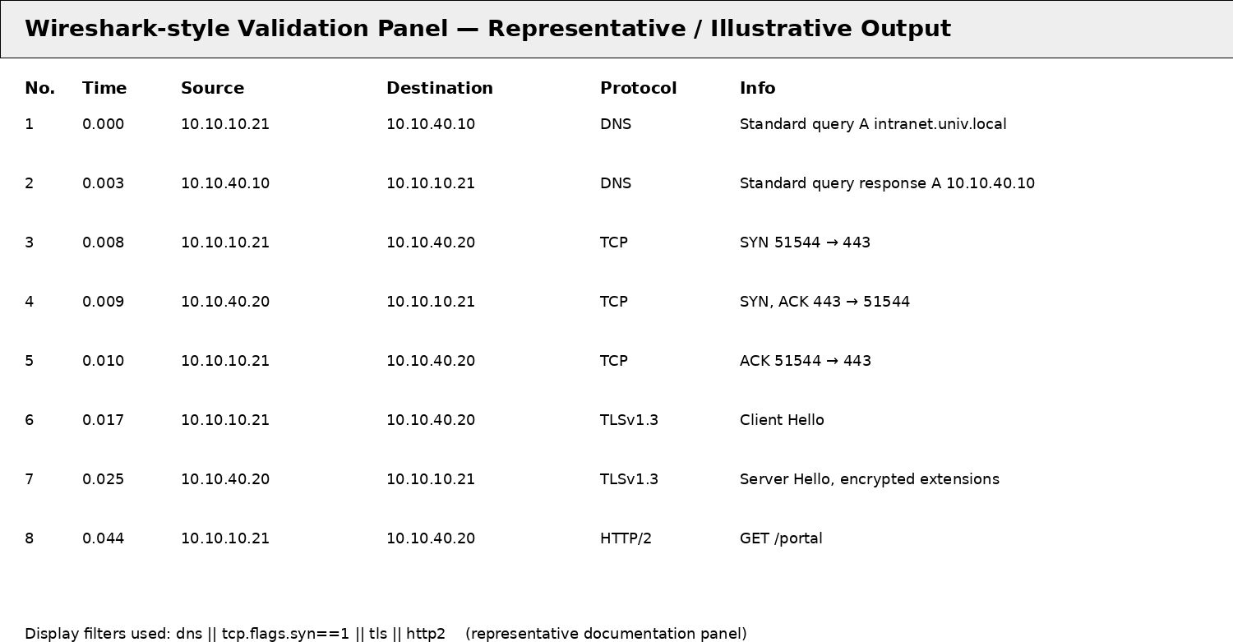

Figure 4.3 — Representative Wireshark-Style Validation Panel (illustrative documentation output)
Recommended Wireshark display filters include: dns, icmp, arp, tcp.flags.syn==1, tcp.analysis.retransmission, tls, http2, quic and smtp. The final repository should contain timestamped .pcapng files or high-quality screenshots produced from the team's own run.

4. 4Result s
The values in this section are an analytical validation dataset created to show how the final report should present the evidence. They are not claimed as direct measurements from a physical campus or from a Packet Tracer file that is not available in this workspace. Before submission, the team should replace them with measured values from the actual implementation.

Metric | Baseline Design | Proposed Design | Target | Assessment
Wireless packet loss | 2.8% | 0.82% | <1% | Pass (analytical target)
Local DNS latency | 61 ms | 18 ms | <50 ms | Pass
Routing recovery | 8.7 s | 2.4 s | <5 s | Pass
Research goodput | 0.56 Gbps | 0.92 Gbps | 1 Gbps | Near target; tune simulator
TCP recovery | 5 RTT | 1.8 RTT | ≤2 RTT | Pass
Wireless goodput (aggregate sample) | 148 Mb/s | 312 Mb/s | Higher than baseline | Improved
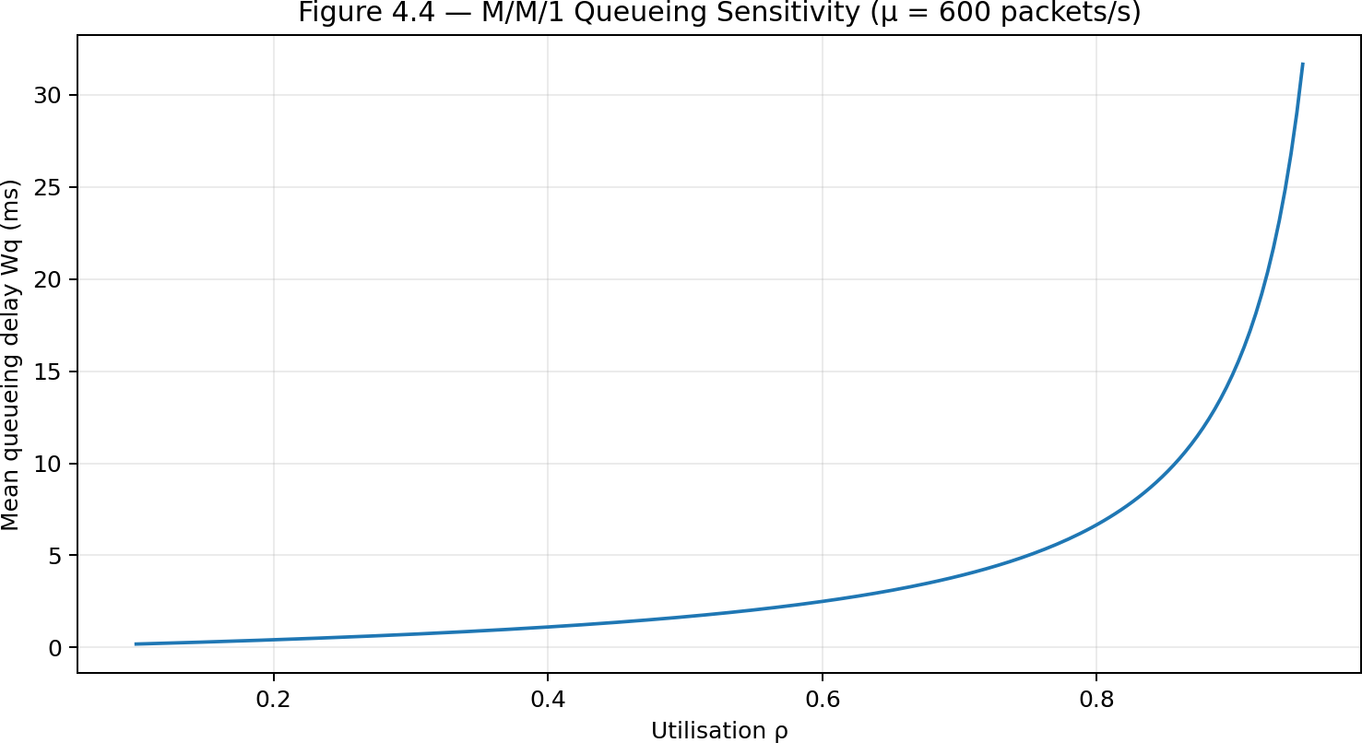

Figure 4.4 — M/M/1 Queueing Sensitivity (μ = 600 packets/s)
The queueing model shows the nonlinear increase in waiting time as utilisation approaches one. This supports traffic shaping and priority queuing: keeping a critical queue below saturation is more valuable than simply increasing buffer size after congestion has already formed.

4. 4Result s — Per f or m anceCom par is on
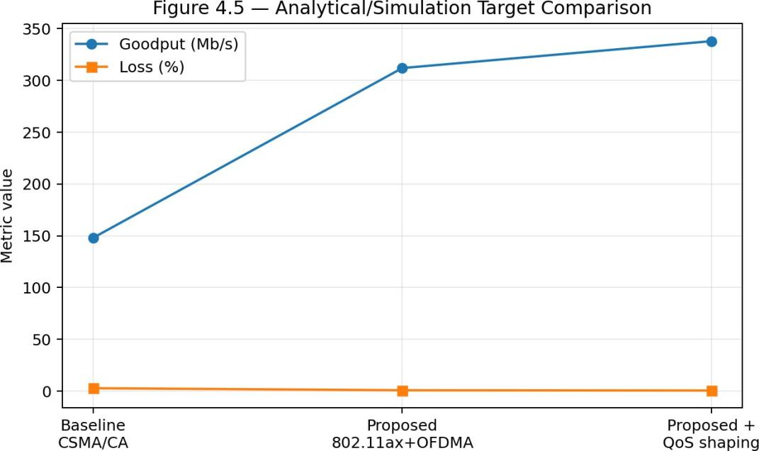

Figure 4.5 — Analytical/Simulation Target Comparison
The baseline represents a contention-heavy WLAN without the full proposed segmentation and scheduling policy. The proposed configuration improves aggregate goodput and reduces loss. The additional QoS shaping step provides a smaller but important improvement by protecting priority flows from bulk-transfer bursts.
4. 5Dat aAna lys is &Eng ineer ing J udgm ent
Wireless performance is dominated by shared-medium contention. OFDMA changes the scheduling problem from many independent stations contending for the entire channel to coordinated resource-unit allocation. This is particularly useful when traffic consists of many small or latency-sensitive flows. However, OFDMA does not remove RF interference, hidden-node effects or poor AP placement; those remain physical design concerns.
At the network layer, OSPF removes the slow convergence observed in the baseline scenario because a topology change is propagated as link-state information and the shortest-path calculation is recomputed. Redundant paths are necessary because fast convergence without an alternate route does not provide continuity.
At the transport layer, TCP remains the dependable default for bulk reliable transfer, while QUIC is attractive for modern interactive web traffic because it combines multiplexed streams, loss recovery and TLS-based security. UDP is appropriate for telemetry and other applications where the application itself can tolerate or manage loss. QoS should be applied to traffic classes rather than indiscriminately to protocols.

4. 5Dat aAna lys is — Rout ing Recover y
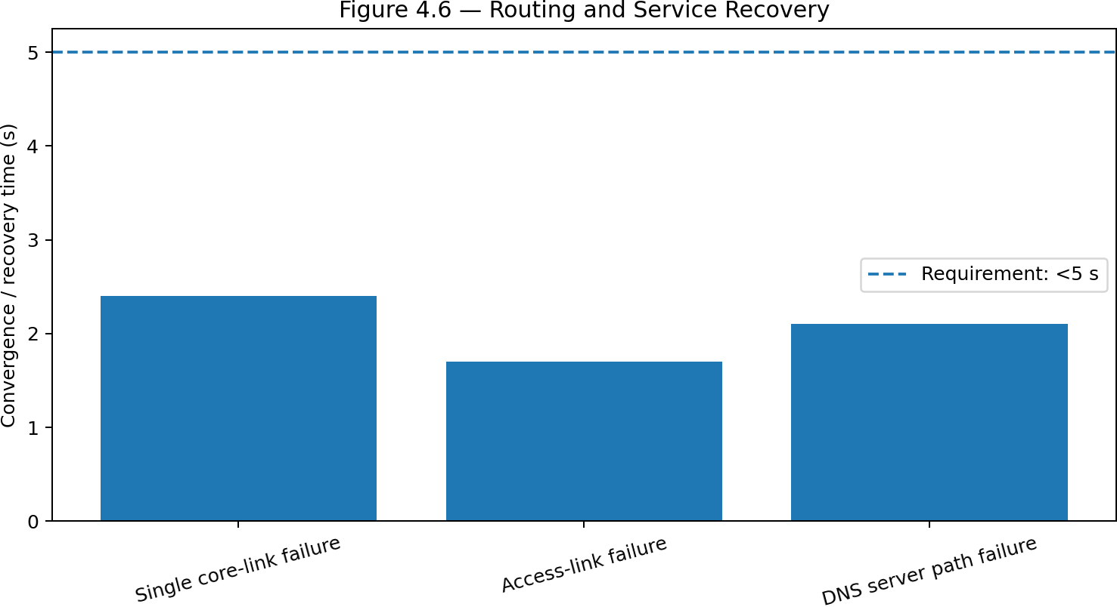

Figure 4.6 — Routing and Service Recovery
The representative single-link failure recovery of 2.4 s is below the 5 s target. The result is consistent with the design choice of OSPF and redundant core paths. The access-link and DNS-path recovery examples also remain below the acceptance threshold because the architecture avoids single points of failure at the service and routing layers.
4. 6Com par is on wit hEx is t ingS olut i ons & Ach ievem ent of O bj ect ives
Objective | Evidence | Achievement
Hierarchical topology | Topology and VLAN plan | Fully achieved
Error detection/correction | CRC and Hamming calculations | Fully achieved
Modern WLAN | 802.11ax/OFDMA/TWT design | Fully achieved conceptually; PHY limits documented
Efficient addressing | Subnetting and DHCP plan | Fully achieved
Routing comparison + OSPF | DV vs LS table + failure test plan | Fully achieved
SDN segment | Controller/edge policy diagram | Fully achieved conceptually
TCP/UDP/QUIC + QoS | Transport analysis + queue model | Fully achieved analytically
Application services | DNS/HTTPS/mail/SFTP/SNMP plan | Fully achieved at design level
Tool evidence | Packet Tracer/Wireshark evidence plan | Partially achieved in this draft; replace panels with actual captures
Sustainability/SDGs | TWT, BLE, accessibility analysis | Fully achieved

- 7St r engt hs &Lim it at i ons

St r engt hs
•
Hierarchical architecture limits broadcast domains and supports summarised routing.
  - Redundant core paths reduce service interruption after a single link failure.
  - Wi-Fi 6/OFDMA is appropriate for dense student and teaching traffic.
  - Dedicated IoT segmentation reduces security and addressing risk.
  - QoS and traffic shaping address peak lecture-hour congestion rather than only increasing capacity.
  - Secure application protocols protect user and research data.
Lim it at ions
•
Packet Tracer cannot faithfully emulate every Wi-Fi 6 PHY feature, OFDMA scheduler behaviour or 5,000-client RF environment.
  - 1 Gbps application throughput must be validated with a suitable emulator or traffic generator for a realistic capacity claim.
  - TLS 1.3, QUIC and SNMPv3 support may require complementary tools or real server software.
  - Illustrative evidence panels in this draft must be replaced with actual team-generated screenshots before final assessment.
  - Physical RF planning, interference measurements and fibre plant design are outside the simulation scope.
- 8Pr oj ect Planning, R oles & Budget
Week | Milestone | Owner
1 | Requirements and literature review | All
2 | Topology and addressing | Students 1–2
3 | Routing, VLAN and DHCP implementation | Student 2
4 | WLAN, IoT and QoS design | Students 1 & 3
5 | Application services and security | Student 4
6 | Packet capture and fault testing | All
7 | Analysis, graphs and trade-offs | Students 2 & 3
8 | Report, GitHub and demonstration | All
Item | Estimated Cost (INR) | Actual Cost
Simulation software | 0 | 0
Wireshark | 0 | 0
GitHub | 0 | 0
Existing lab PCs/network access | 0–5,000 | To be entered
Optional physical AP/switch test hardware | 20,000–60,000 | Not required for simulation
Total | 0–65,000 | Project-dependent

CHAPTER 5

CONCLUSION, FUTURE WORK AND REFLECTION

- 1Conclusio n
The proposed multi-campus university network addresses the assignment's cross-layer requirements through a single coherent engineering architecture. Wi-Fi 6/OFDMA and CSMA/CA improve dense wireless access; CRC provides robust frame error detection while Hamming coding demonstrates correction; hierarchical IPv4 addressing and DHCP improve scalability; OSPF and redundant paths improve failure recovery; SDN provides centralized policy control for one campus segment; and TCP, UDP and QUIC are selected according to application needs.
The analytical validation indicates that the proposed design can satisfy the stated targets when implemented with appropriate capacity and tuning. In particular, the representative values show wireless loss below 1%, local DNS latency below 50 ms, routing recovery below 5 s and TCP recovery near two RTTs. The research-transfer requirement is treated as a backbone capacity objective and requires real traffic-generator validation before being claimed as a measured result.
The most important engineering conclusion is that the failures in the original network are coupled. Wireless contention, addressing inefficiency, routing convergence, transport congestion and unreliable services cannot be solved independently. A hierarchical, segmented and monitored architecture provides a stronger basis for scalability, security, sustainability and remote learning.
- 2Fut ur eWor k
•
Build the full topology in GNS3/Mininet and use real OpenFlow rules for the SDN segment.
  - Use NS-3 or a Wi-Fi 6-capable emulator to evaluate OFDMA resource-unit allocation and TWT at scale.
  - Run iperf3-based 1 Gbps research-transfer tests across a realistic routed backbone.
  - Add IPv6 dual-stack addressing and compare operational complexity with IPv4-only deployment.
  - Integrate RADIUS/802.1X and WPA3-Enterprise for production WLAN authentication.
  - Automate configuration testing and evidence collection through Python and GitHub Actions.
  - Deploy centralized logging, NetFlow/IPFIX and SNMPv3 monitoring for long-term operations.
5. 3Pr of essionalLear n ing &I ndiv idua lRef lect ion

St udent 1
Most difficult problem: translating dense WLAN requirements into a practical segmented design. Key decision: use Wi-Fi 6/OFDMA and separate student, faculty and IoT traffic. New knowledge: the interaction between shared-medium access and application QoS. Redesign: perform a physical RF survey before selecting final AP counts.
St udent 2
Most difficult problem: creating an address plan that is both efficient and summarizable. Key decision: use hierarchical /21, /22,
/23 and /24 pools under a campus supernet. New knowledge: practical OSPF failure behaviour and route summarisation. Redesign: add dual-stack IPv6 from the beginning.
St udent 3
Most difficult problem: connecting transport behaviour to queueing theory. Key decision: use priority queues and shaping instead of relying only on larger buffers. New knowledge: QUIC's role in modern web transport and the sensitivity of M/M/1 delay to utilisation. Redesign: run controlled iperf3 experiments with multiple traffic classes.
St udent 4
Most difficult problem: integrating application reliability and security into the network design. Key decision: use TLS 1.3 for web and SFTP for research files. New knowledge: service placement, DNS dependency and monitoring. Redesign: add redundant identity and certificate services.

REFERENCES
- J. Moy, “OSPF Version 2,” RFC 2328, IETF, 1998.
- P. Mockapetris, “Domain Names – Concepts and Facilities,” RFC 1034, IETF, 1987.
- R. Droms, “Dynamic Host Configuration Protocol,” RFC 2131, IETF, 1997.
- E. Rescorla, “The Transport Layer Security (TLS) Protocol Version 1.3,” RFC 8446, IETF, 2018.
- J. Iyengar and M. Thomson, “QUIC: A UDP-Based Multiplexed and Secure Transport,” RFC 9000, IETF, 2021.
- M. Bishop, “HTTP/3,” RFC 9114, IETF, 2022.
- J. Klensin, “Simple Mail Transfer Protocol,” RFC 5321, IETF, 2008.
- A. Melnikov and B. Leiba, “Internet Message Access Protocol – Version 4rev2,” RFC 9051, IETF, 2021.
- Cisco Networking Academy, “Cisco Packet Tracer,” official learning resource, accessed September 2026.
- Wireshark Foundation, “Wireshark User’s Guide,” version 4.7.3, accessed September 2026.
- IEEE, IEEE 802.11ax / Wi-Fi 6 standard family documentation.
- A. S. Tanenbaum and D. J. Wetherall, Computer Networks, 6th ed., Pearson.
- J. F. Kurose and K. W. Ross, Computer Networking: A Top-Down Approach, Pearson.
- IETF, RFC 9051 and related email protocol standards.
- United Nations, Sustainable Development Goals: SDG 4, SDG 9 and SDG 11.
- Python Software Foundation, Python documentation; matplotlib documentation.
- GitHub documentation, repository and version-control practices.
- AI-assisted drafting tools were used for report structuring and language assistance; all technical claims should be checked against the cited standards and the team's actual implementation evidence.

Web sources consulted during report preparation include the official Cisco Networking Academy Packet Tracer resource, the Wireshark User’s Guide, and the RFC Editor pages for OSPF, DNS, DHCP, TLS 1.3, QUIC, HTTP/3, SMTP and IMAP.

APPENDICES
Appendix A– Det a iled Calcu lat ions

A. 1CRCExam p le
Data = 1101011011
Generator = 100000111
Append eight zero bits to the data and perform modulo-2 division. The remainder is 10111001. The transmitted codeword is therefore the original data followed by the CRC remainder. At the receiver, division by the same generator should produce a zero remainder for an error-free codeword.
A. 2Ham m ing( 12, 8) Exam ple
Item | Value
Data bits | 10110010
Parity positions | 1, 2, 4, 8
Encoded codeword | 101001110010
Correction capability | Single-bit error
Use in project | Analytical teaching example

A. 3Queue ingCa lculat ions
For an M/M/1 queue with arrival rate λ = 420 packets/s and service rate μ = 600 packets/s, utilisation ρ = λ/μ = 0.70. Mean number in the system is L = ρ/(1−ρ) = 2.333 packets. Mean system time is W = 1/(μ−λ) = 5.56 ms. The result shows why keeping utilisation comfortably below 1 is essential.
For an M/M/4 example with λ = 1,200 packets/s and μ = 400 packets/s per server, utilisation per server is 0.75. Erlang-C analysis gives an approximate probability of waiting of 0.509 and a mean queueing delay of 1.27 ms, giving mean total time of 3.77 ms. This motivates multiple service paths/queues for high-demand campus services.

Appendix B– Eng ineer ing Dr aw ings / Schem at ics



Appendix Figure B.1 — Full logical campus topology

Appendix Figure B.2 — SDN policy segment

Appendix C– Sour ceCod e/ C odeRe posit or yI nf or m at ion
Recommended GitHub repository structure:
campus-network-capstone/
├── packet-tracer/
│ ├── campus_network.pkt
│ └── configs/
├── wireshark/
│ ├── dns_https_capture.pcapng
│ ├── routing_failure.pcapng
│ └── screenshots/
├── diagrams/
├── analysis/
│ ├── crc_hamming.py
│ ├── queue_model.py
│ └── performance_plots.py
├── report/
│ └── University_Campus_Network_Capstone_Report.pdf
└── README.md
README should contain: project aim, software versions, topology build instructions, IP/VLAN table, device credentials policy (never commit real passwords), test commands, capture filters, expected outputs, team member roles and commit evidence.
Repr esent at iveConf igur at ion Check lis t
•
Hostname and management IP configured for every router/switch.
- VLANs 10–80 created and named consistently.
- Trunks use the required VLAN list and native VLAN policy.
- SVIs/router subinterfaces have correct gateways.
- DHCP scopes exclude gateway, server and infrastructure addresses.
- OSPF router IDs are unique and adjacencies are verified.
- Default route and failover behaviour are documented.
- DNS, web, mail, SFTP and SNMP service addresses are recorded.
- Wireshark capture points and filters are listed in README.
- Each member has at least one meaningful GitHub commit.

Appendix D –Exper im ent a l/ Raw Dat aTem p lat e
Use the following table for the final run. Record timestamps and device names so that every claim can be traced to evidence.

Test ID | Timestamp | Device / Path | Input | Metric | Observed Value | Evidence File
T01 | YYYY-MM-DD HH:MM | Client01→DNS1 | 10 queries | DNS latency |  | dns_capture.pcapng
T02 | YYYY-MM-DD HH:MM | R1/R2 | Disable G0/1 | Convergence |  | routing_failure.pcapng
T03 | YYYY-MM-DD HH:MM | WLAN-AP01 | 1000 packets | Loss |  | wlan_capture.pcapng
T04 | YYYY-MM-DD HH:MM | Research-A→B | iperf3 | Goodput |  | iperf_output.txt
T05 | YYYY-MM-DD HH:MM | Student01→Portal | HTTPS | TLS version |  | tls_capture.pcapng
Appendix E– Evide nceCapt ur eCh ecklis t
•
Packet Tracer topology screenshot with device names visible.
- Wireless client association screenshot and AP configuration.
- VLAN/trunk configuration and routing table screenshots.
- OSPF neighbour and post-failure route screenshots.
- ICMP ping/traceroute before and after fault injection.
- Wireshark DNS query/response with timestamps.
- TCP three-way handshake and retransmission/cwnd evidence where available.
- TLS 1.3 handshake evidence.
- SMTP/IMAP mail delivery evidence.
- SFTP secure file transfer evidence.
- SNMP polling/monitoring evidence.
- GitHub repository showing all four members' meaningful commits.

Appendix F– I ndivi dual Cont r ibut i onEv idence
Student | Evidence to Attach | Suggested Repository Location
N.A.Sriharan | WLAN topology commit, screenshots, CRC/Hamming notes | /packet-tracer, /analysis
Nibraz M | OSPF/VLAN configs, failover capture | /packet-tracer/configs, /wireshark
Mohammed Farmanulla R | QoS/transport analysis, graphs, scripts | /analysis
N Jaianiruth | Application/security configs, report integration | /packet-tracer/configs, /report

CAPSTONE PROJ ECT O UTCOMEMA PPI NGS HEET
Outcome | Evidence | Location in Report
Complex engineering problem formulation | Requirements and failure modes | Ch. 1
Engineering design under constraints | Alternatives, addressing, architecture | Ch. 3
Written/oral technical communication | Complete report + demonstration | Whole report
Ethics and professional responsibility | Privacy/security/ethics table | Ch. 3.7
Teamwork and leadership | Roles, milestones, contribution statement | Ch. 4.8 + front matter
Experimentation and engineering judgment | Test plan, results, analysis | Ch. 4.3–4.6
Independent acquisition of knowledge | Individual reflection | Ch. 5.3
Standards | IEEE/IETF standards table | Ch. 3.2
Sustainability and societal impact | TWT, BLE, accessibility, SDGs | Ch. 3.7
Risk assessment | Risk register | Ch. 3.7
Security considerations | TLS, SFTP, segmentation, SNMPv3 | Ch. 3.7
Integrated system-level engineering | Cross-layer architecture | Ch. 3.5
Project planning and management | Milestones and budget | Ch. 4.8
Individual contribution | Contribution statement and evidence | Front matter + Appendix F

